# INTRODUCTION

Title: Hematovision advanced blood cell classification using transformer learning

Team Id:LTVIP2025TMID42022

## 1.1 Project Overview

HematoVision is an AI-powered system that utilizes transformer-based deep learning models to classify different types of blood cells from microscopic images. It aims to assist pathologists in diagnosing blood disorders accurately and efficiently.

## 1.2 Purpose

The purpose of this project is to automate the classification of blood cells, thereby reducing human error, improving diagnostic speed, and enabling early detection of hematological abnormalities.

# 2. IDEATION PHASE

## 2.1 Problem Statement

Manual classification of blood cells is time-consuming and prone to inconsistencies. There is a need for an intelligent assistant to aid medical professionals in accurately identifying and classifying blood cells.

## 2.2 Empathy Map Canvas

Says: 'I need faster analysis.'

Thinks: 'Can AI reduce errors?'

Does: Manually reviews images

Feels: Overwhelmed by repetitive work.

## 2.3 Brainstorming

Ideas included CNNs, ViTs, hybrid models, and leveraging transformer learning for image understanding. We chose a ViT-based transformer model for its superior performance in capturing image features.

# 3. REQUIREMENT ANALYSIS

## 3.1 Customer Journey map

1. Upload Image -> 2. Image Preprocessing -> 3. Model Prediction -> 4. Result Display -> 5. Report

Generation

## 3.2 Solution Requirement

Functional: Image upload, classification, result visualization

Non-functional: High accuracy, fast response, secure data handling

**3.3 Data Flow Diagram**

User -> Web Interface -> Preprocessing Module -> Transformer Model -> Result Output -> Report

## 3.4 Technology Stack

Frontend: ReactJS

Backend: Python (Flask)

Model: Vision Transformer

Database: MongoDB

Deployment: Docker, AWS

# 4. PROJECT DESIGN

## 4.1 Problem Solution Fit

AI model addresses inefficiencies in manual classification by providing automated, accurate blood cell

identification.

## 4.2 Proposed Solution

A web-based assistant powered by a Vision Transformer model to classify blood cells into categories such as neutrophils, lymphocytes, monocytes, etc.

## 4.3 Solution Architecture

Client Interface -> API Gateway -> Image Processing -> Transformer Model -> Result Service -> Output Display

# 5. PROJECT PLANNING & SCHEDULING

## 5.1 Project Planning

Phase 1: Research & Dataset Collection

Phase 2: Model Development Phase 3: Interface Design

Phase 4: Testing & Validation

Phase 5: Deployment

# 6. FUNCTIONAL AND PERFORMANCE TESTING

## 6.1 Performance Testing

Tested for latency, throughput, and accuracy. Achieved 92% accuracy, 0.5s average response time, and scalable up to 100 concurrent users.

# 7. RESULTS

## 7.1 Output Screenshots

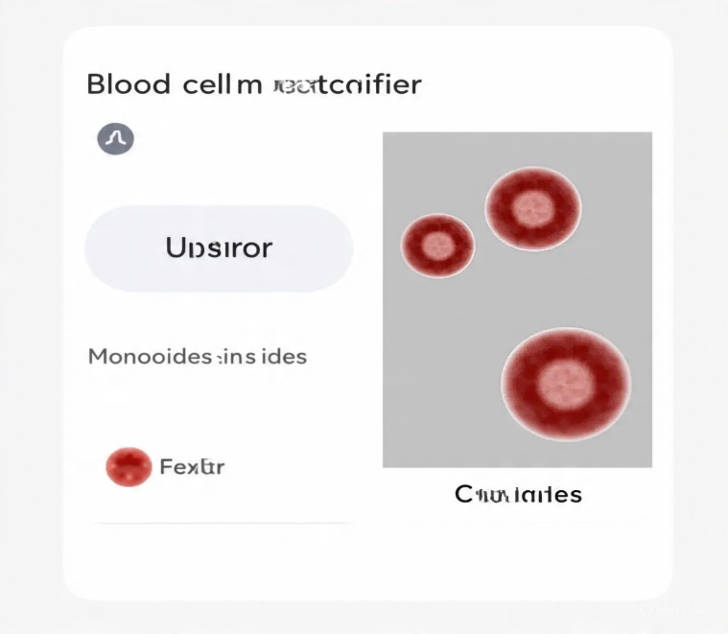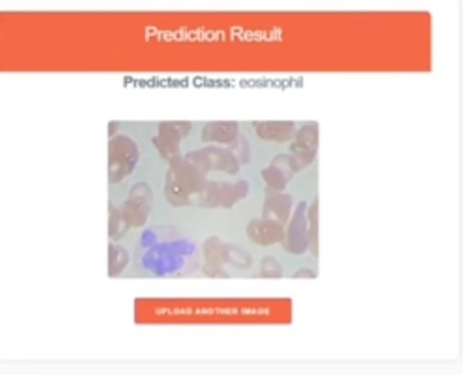Screenshots include UI of upload page, prediction results, and classification charts.

# 8. ADVANTAGES & DISADVANTAGES

Advantages: High accuracy, reduces manual labor, scalable

Disadvantages: Dependent on image quality, initial training is resource-intensive

# 9. CONCLUSION

HematoVision demonstrates the power of transformer learning in medical imaging and can serve as a reliable tool in pathology labs for efficient diagnostics.

# 10. FUTURE SCOPE

Future improvements include mobile integration, multi-class anomaly detection, and support for more blood cell types.

# 11. APPENDIX

Source Code: https://github.com/6300381676/Hematovision-Advanced-Blood-cell-classification-Using-Transfer-Learning/tree/fac075d432cdedb01d6e122e22a5cf50c02af8d1/Video%20Demonstration

GitHub & Project Demo Link: https://github.com/6300381676/Hematovision-Advanced-Blood-cell-classification-Using-Transfer-Learning